Find a partner and answer the following questions as a team:

Your name:   
Lab teammate’s name:

1. Using Window/File Explorer and the computer properties, determine the processor type and speed of your desktop computer. Record it here:
   1. 2015 MacBook Pro:
      1. Intel Core i7 quad core
      2. 2.5GHz
2. Locate a picture of an IEEE 1394 port or connector on the Internet. Provide an image of the port/connector, the URL where you found it and what it can be used for.
   1. URL: <http://hardwaretexpert.blogspot.com/2011/01/what-is-firewire.html>
   2. 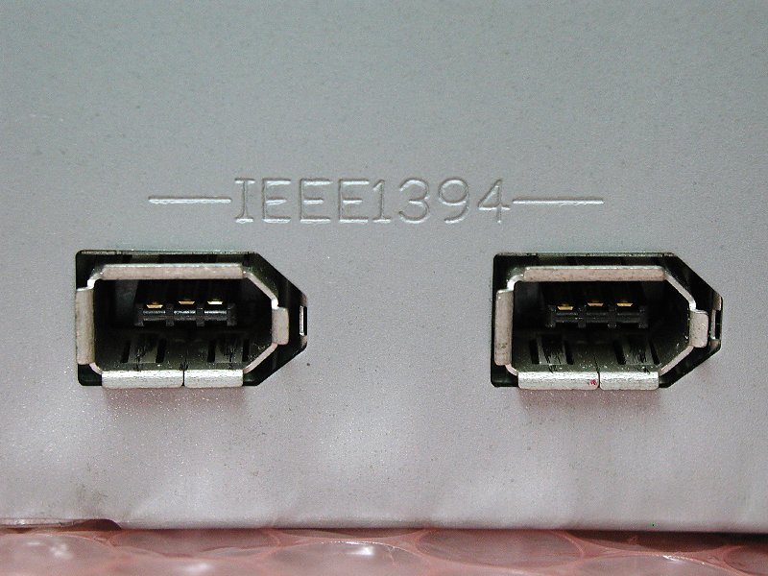
3. What are two functions of a chipset?
   1. Chipsets control the maximum amount of motherboard memory.
   2. Chipsets also control the motherboards capacity for multiple CPUs.
4. List each letter with the name of the port:
   1. 6-Pin mini-DIN combo port
   2. USB Ports
   3. Optical S/PDIF
   4. HDMI Port
   5. VGA Port
   6. DIV Port
   7. USB 3.0
   8. RJ-45 Network Port
   9. Center Speaker or Subwoofer
   10. Rear Speaker
   11. Side Speaker
   12. Line In
   13. Line Out
   14. Microphone

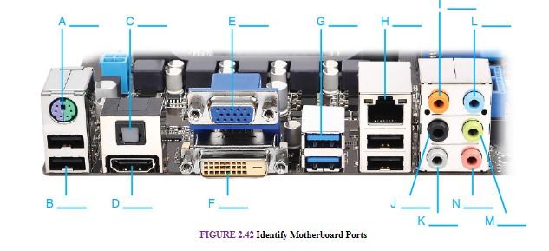

1. What is this port used for?
   1. Thunderbolt, it is the same as a mini-display port which is an updated form of display port. Data for both video, sound, and files can be shared over this connection.



1. Why would you use CPU throttling?
   1. If they want to conserve power when the CPU is not under heavy load.
   2. If they have a cooling issue and cannot properly cool the CPU, throttling will limit the work load and help keep the temperature down.
2. List three cooling methods used for processors. Why must processors be cooled?
   1. Heat Pipe
   2. Passive Cooling
   3. Liquid Cooling
   4. Keeping a processor cool will help it perform better at higher clock speeds as well as helping it’s lifespan.
3. 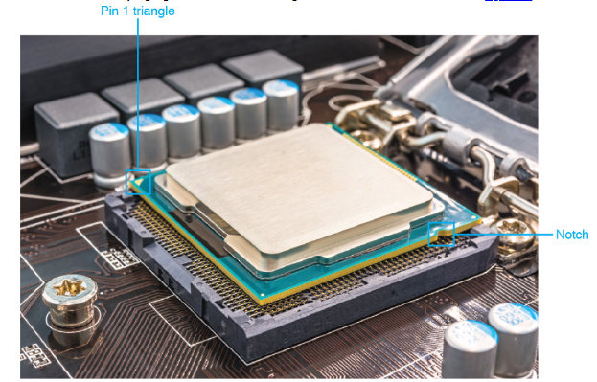What is the “notch” used for on a processor?

The notches help align the processor with the socket to make sure it is connected properly.

1. Explain the difference between PCI and PCIe:
   1. PCI is a half-duplex bidirectional, which means that it can only send a receive one direction at a time.
   2. PCIe is full-duplex bidirectional, it can send a receive data at the same time.
2. Explain form factors:
   1. There are many different form-factors of motherboards. ATX (the most common), micro-atx, ITX, etc. This lets you know what size the motherboard is and what kind of case it will be able to fit into. This comes into play when you actual space for the whole computer is limited.

What is one topic from Chapter 3 – Motherboards that you and your teammate are “fuzzy” on? List this item, read the text and do some research to further your understanding. Record the topic and new understanding of it.